NAME: ____SANDHIYA .R___
ROLL NO: ___E25AI140_____
TASK:_ ____WEEK 2 TASK____
SUBJECT: ___DBMS_______

WEEK 2 PROJECT REPORT

Product and Category Management System

The Product and Category Management System is an SQL-based project designed for an e-commerce company.
The system maintains information about products and their categories. Each product belongs to a specific category, and the system stores product details such as product name, price, stock availability, and category.

Database Design
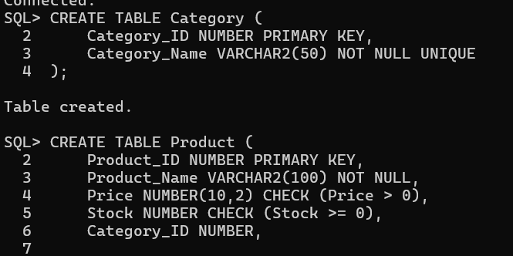

Inserting Product Values:
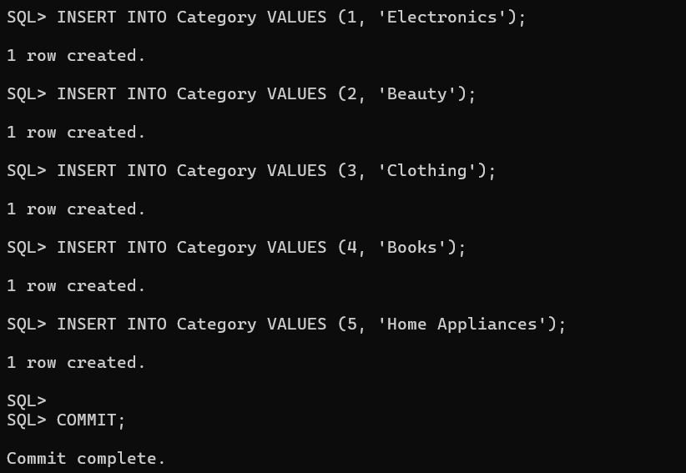
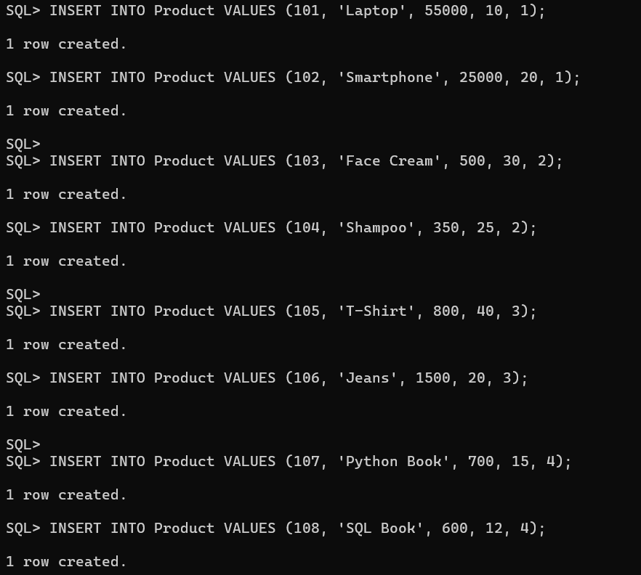
CRUD Operations

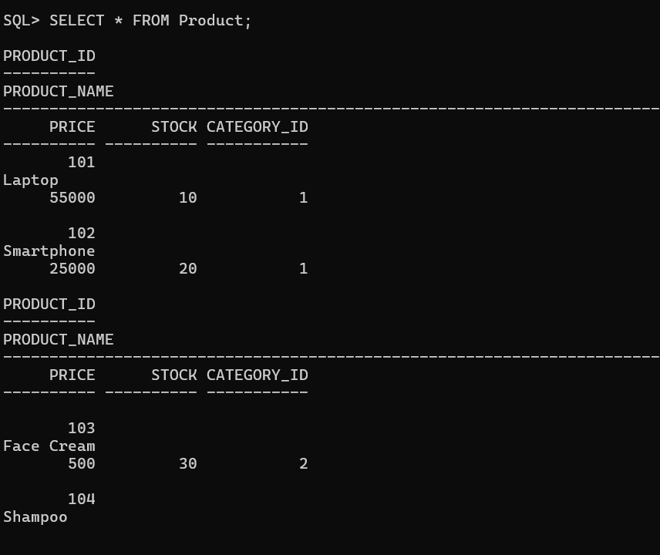


UPDATE:
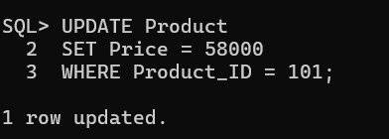
Delete:
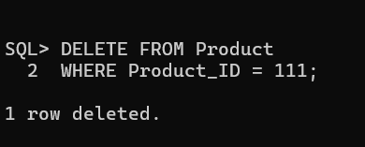

Category-wise Product Reports:
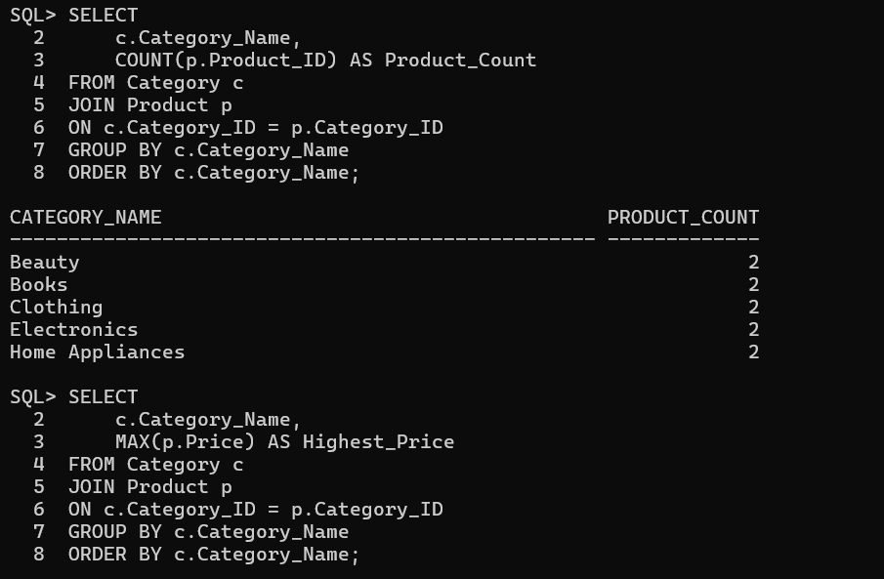

Average Product Price Category-wise
